ASSIGNMENT 4

AIM 1:- Write a program to perform following operation on image by giving options1, 2 and 3.

1.Negative of image 2.Log transformation 3.Power law(gamma) transformation

Code:-

x=input('PRESS::1.NEGATIVE.2.LOG TRANSFORMATION.3.GAMMA TRANSFORMATION:');

if x==1

a=uigetfile('*.*','Select the Image');

a=imread(a);

[r,c]=size(a);

for i=1:r

for j=1:c

new(i,j)=255-a(i,j);

end

end

subplot(121);

title('ORIGINAL IMAGE');

imshow(a);

subplot(122);

title('NEGATIVE IMAGE');

imshow(new);

elseif x==2

a=imread(uigetfile('*.*','Select the Image'));

a1=double(a);

sz=size(a1);

new=ones(sz(1),sz(2));

c1=10;

for i=1:sz(1)

for j=1:sz(2)

p1 = 1+a1(i,j);

new(i,j)= c1 * log(p1);

end

end

imshow(mat2gray(new));

elseif x==3

Y =0.6;

Y1=0.4;

Y2=0.3;

c1=1;

new=ones(sz(1),sz(2));

new1=ones(sz(1),sz(2));

new2=ones(sz(1),sz(2));

a=imread(uigetfile('*.*','Select the Image'));

a1=im2double(a);

sz=size(a1);

for i=1:sz(1)

for j=1:sz(2)

new(i,j)= c1 .* a1(i,j)^Y;

new1(i,j)= c1 .* a1(i,j)^Y1;

new2(i,j)= c1 .* a1(i,j)^Y2;

end

end

subplot(221);

title('ORIGINAL IMAGE');

imshow(a);

subplot(222);

title('Y=0.6');

imshow(new);

subplot(223);

title('Y=0.4');

imshow(new1);

subplot(224);

title('Y=0.3');

imshow(new2);

end

Output:-

1.Negative Image

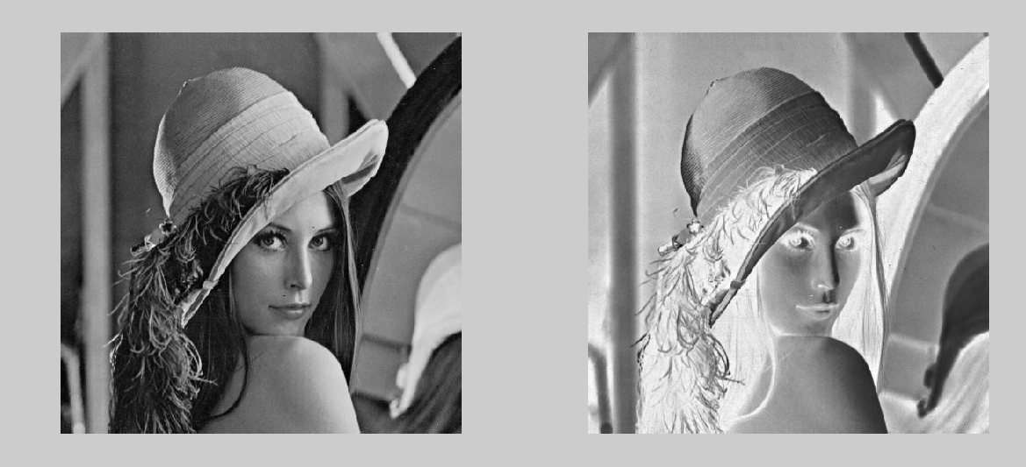

2.Logtransformed image

D:\MAT-DIP-LAB-TVR\Assignment4\beam.tif

[ORIGINAL IMAGE]

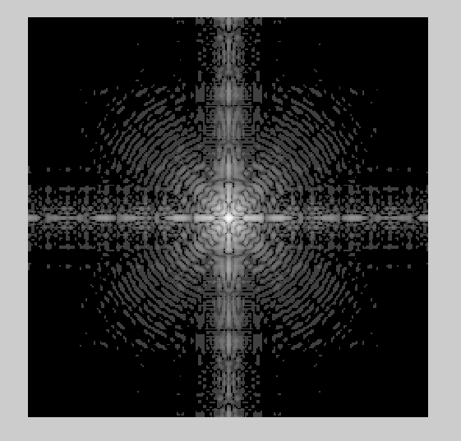

[LOGTRANSFORMED IMAGE]

3.Gamma transformation

[ORIGINAL IMAGE] [y=0.6]

   
[y=0.4] [y=0.3]

AIM 2:-Write a program which demonstrate the use of contrast stretching transformation.

Code:-

clear all

close all

clc

y=imread('rice.tif');

imshow(y);

[m n]=size(y);

%%%%%%%%%%Contrast Stretching%%%%%%%%%%%

a=input('Enter the value of input graylevel r1 for contrast stretching:');

b=input('Enter the value of input graylevel r2 for contrast stretching:');

for i=1:m

for j=1:n

if y(i,j)<=a

zz(i,j)=0.5*y(i,j);

else if y(i,j)<=b

zz(i,j)=2*(y(i,j)-a)+0.5*a;

else

zz(i,j)=0.5*(y(i,j)-b)+0.5*a+2*(b-a);

end

end

end

end

figure

imshow(zz)

title('contrast stretched image')

Output:-

D:\MAT-DIP-LAB-TVR\Assignment4\rice.tif

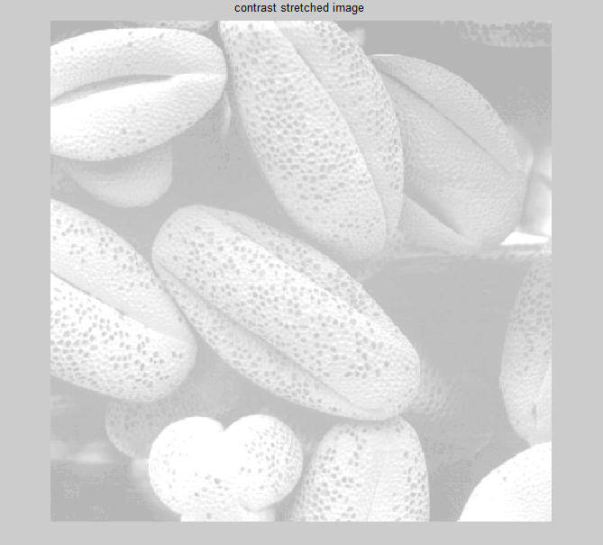

AIM3:- Implement program of Intensity level slicing.

Code:-

i=imread('lena.jpg');

[row col byt]=size(j) ;

T1=input('enter the Lowest threshold value:') ;

T2=input('enter the Highest threshold value:')

for x=1:1:row

for y=1:1:col

if((j(x,y)>T1) && (j(x,y)<T2))

j(x,y)=255;

else

j(x,y)=i(x,y);

end

end

end

figure; imshow(i); % original image

figure; imshow(uint8(j)) % gray level slicing with background

Output:-

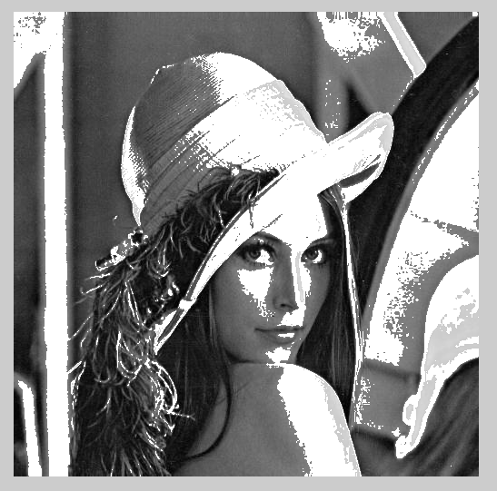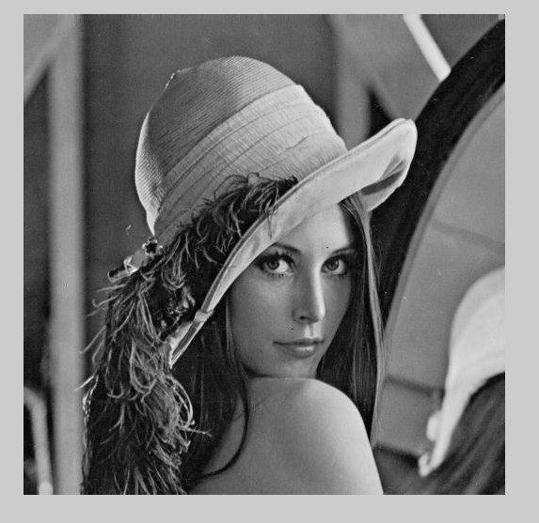

[Original Image] [Resultant Image]

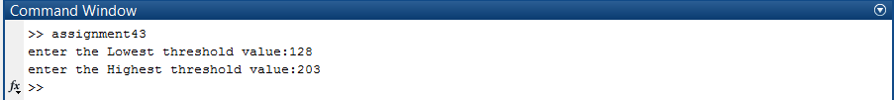

AIM 4:-Implement program of Bit plane slicing.

Code:-

im=imread('note.tif');

bit1=bitget(im,1);

bit2=bitget(im,2);

bit3=bitget(im,3);

bit4=bitget(im,4);

bit5=bitget(im,5);

bit6=bitget(im,6);

bit7=bitget(im,7);

bit8=bitget(im,8);

figure,imshow(bit1,[]);

figure,imshow(bit2,[]);

figure,imshow(bit3,[]);

figure,imshow(bit4,[]);

figure,imshow(bit5,[]);

figure,imshow(bit6,[]);

figure,imshow(bit7,[]);

figure,imshow(bit8,[]);

Output:-

Bit plane 1:-

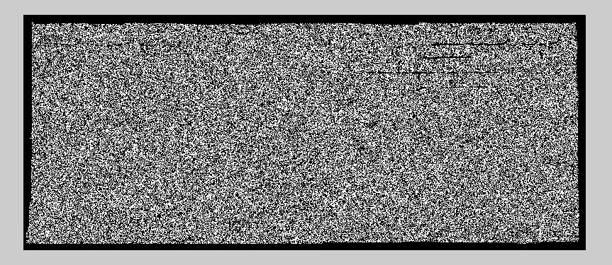

Bit plane 2:-

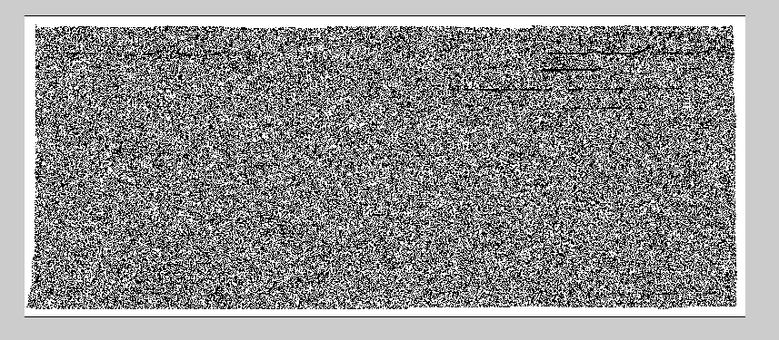

Bit plane 3:-

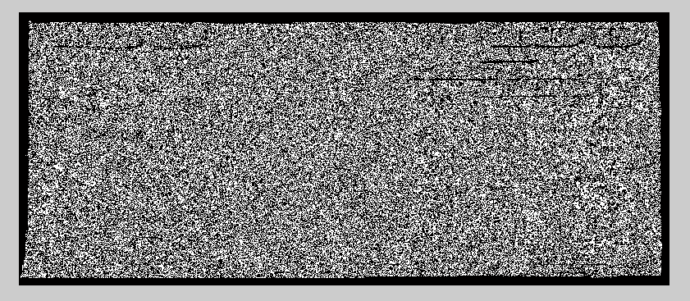

Bit plane 4:-

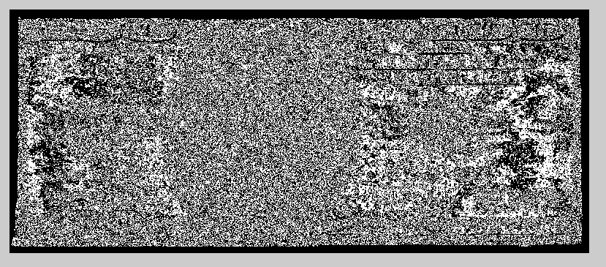

Bit plane 5:-

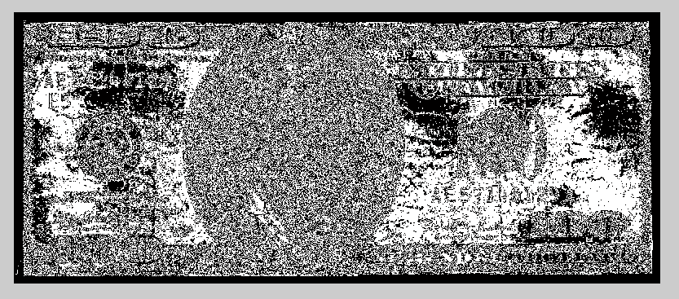

Bit plane 6:-



Bit plane 7:-

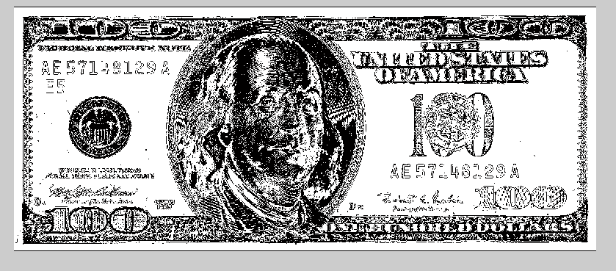

Bit plane 8:-

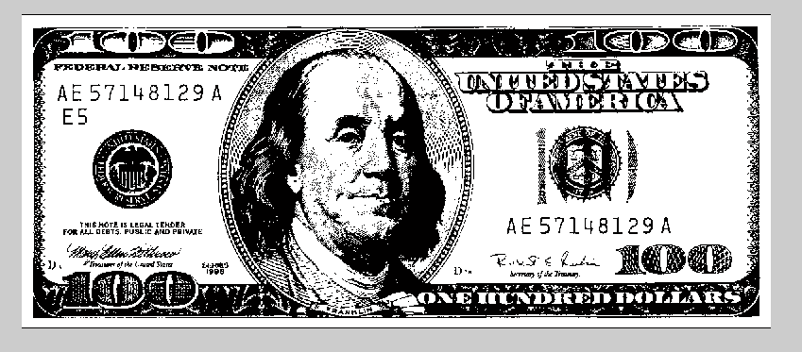

AIM 5:-How to reduce gap between two sub image of subplot. Discuss with Matlab program.

Code:-

clc

clear all

close all

clc

figure,

for ii = 1:6;

subplot(3,2,ii);

plot(randn(10,ii));

end

figure,

ha = tight_subplot(3,2,[.01 .03],[.1 .01],[.01 .01])

for ii = 1:6;

axes(ha(ii));

plot(randn(10,ii));

end

set(ha(1:4),'XTickLabel','');

set(ha,'YTickLabel','')

tight_subplot.m:-

function ha = tight_subplot(Nh, Nw, gap, marg_h, marg_w)

% tight_subplot creates "subplot" axes with adjustable gaps and margins

%

% ha = tight_subplot(Nh, Nw, gap, marg_h, marg_w)

%

% in: Nh number of axes in hight (vertical direction)

% Nw number of axes in width (horizontaldirection)

% gap gaps between the axes in normalized units (0...1)

% or [gap_h gap_w] for different gaps in height and width

% marg_h margins in height in normalized units (0...1)

% or [lower upper] for different lower and upper margins

% marg_w margins in width in normalized units (0...1)

% or [left right] for different left and right margins

%

% out: ha array of handles of the axes objects

% starting from upper left corner, going row-wise as in

% going row-wise as in

%

% Example: ha = tight_subplot(3,2,[.01 .03],[.1 .01],[.01 .01])

% for ii = 1:6; axes(ha(ii)); plot(randn(10,ii)); end

% set(ha(1:4),'XTickLabel',''); set(ha,'YTickLabel','')

% Pekka Kumpulainen 20.6.2010 @tut.fi

% Tampere University of Technology / Automation Science and Engineering

if nargin<3; gap = .02; end

if nargin<4 || isempty(marg_h); marg_h = .05; end

if nargin<5; marg_w = .05; end

if numel(gap)==1;

gap = [gap gap];

end

if numel(marg_w)==1;

marg_w = [marg_w marg_w];

end

if numel(marg_h)==1;

marg_h = [marg_h marg_h];

end

axh = (1-sum(marg_h)-(Nh-1)*gap(1))/Nh;

axw = (1-sum(marg_w)-(Nw-1)*gap(2))/Nw;

py = 1-marg_h(2)-axh;

ha = zeros(Nh*Nw,1);

ii = 0;

for ih = 1:Nh

px = marg_w(1);

for ix = 1:Nw

ii = ii+1;

ha(ii) = axes('Units','normalized', ...

'Position',[px py axw axh], ...

'XTickLabel','', ...

'YTickLabel','');

px = px+axw+gap(2);

end

py = py-axh-gap(1);

end

Output:-

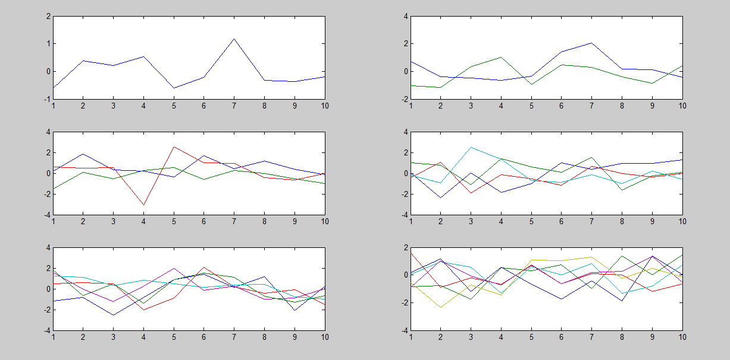

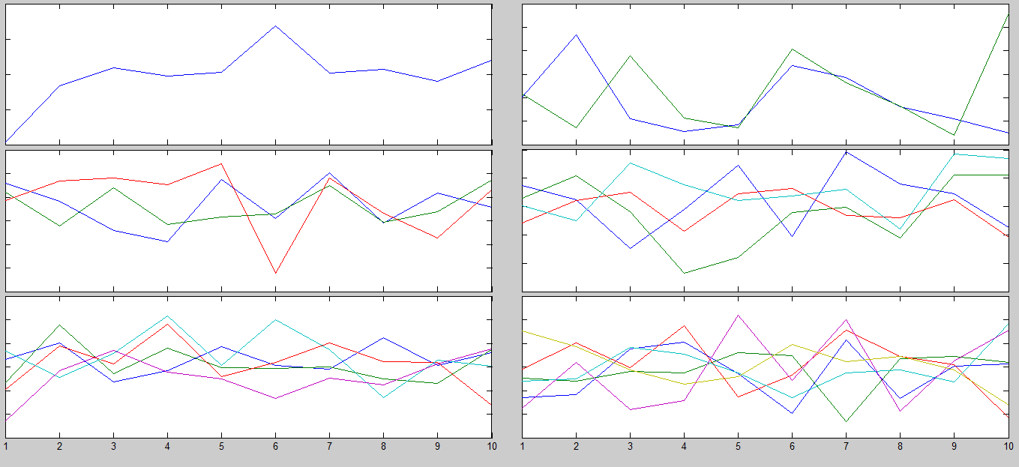

AIM 6:- Write a program which demonstrate the use thresholding technique of for an image.

Code:-

clc;

close all;

clear all;

thr=input('Give the threshold');

I = imread('lena.jpg');

I=I>thr;

figure,imshow(I);

Output:-



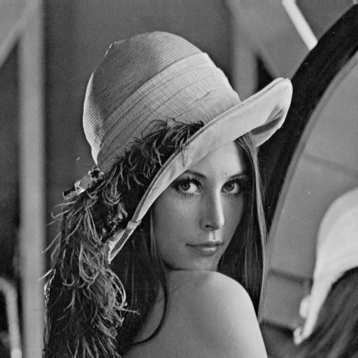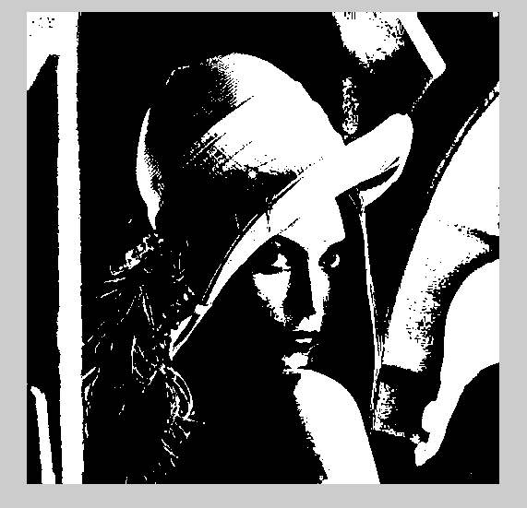

[ORIGINAL IMAGE] [THRESHOLDED IMAGE]